NAME: _____________________________ PERIOD: _______ DATE: _________ POINTS: _______

Map Activity
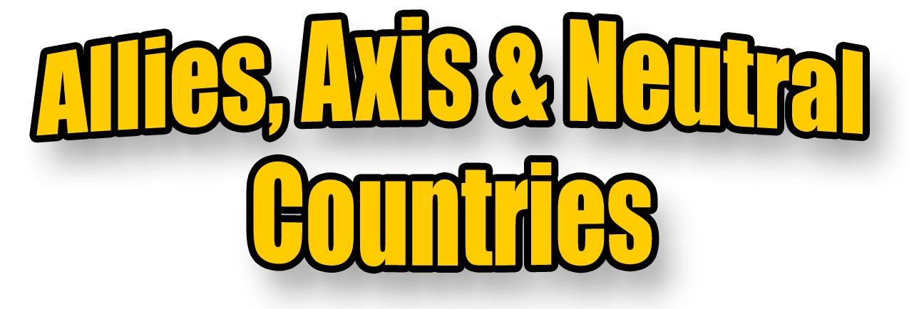
Countries that fought in the Second World War were divided into two sides: the Allies and the Axis. Countries who were not involved in the war were called Neutral Countries.

DIRECTIONS:
1. Select 3 different colors to represent the Allies, the Axis Powers and Neutral Countries. Color in the Map Key with your chosen colors. Example: blue for Allies then color in the box on the map blue.

Axis Powers:
- Germany
- Italy
- Japan

Neutral Countries:
- Republic of Ireland
- Spain
- Sweden
- Switzerland
- Portugal

Allies:
- United Kingdom (Great Britain, Scotland & N. Ireland)
- France
- USSR (Soviet Union, Russia)
- Australia
- Belgium
- Denmark
- Greece
- Netherlands
- Norway
- Poland
- Yugoslavia
- Czechoslovakia
- Estonia
- Latvia
- Lithuania

