Name: __________________________ Period: ________ Date: ___________
Shift in Demand Practice

Directions: Use the following demand data on Frappuccino Coffees to respond to questions below.

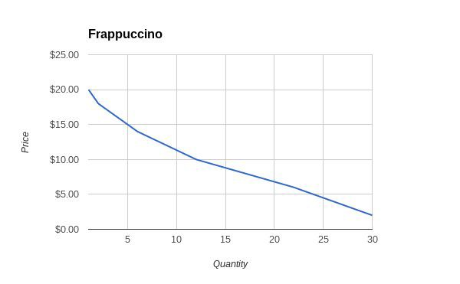
Quantity | Price
1 | $20.00
2 | $18.00
4 | $16.00
6 | $14.00
9 | $12.00
12 | $10.00
17 | $8.00
22 | $6.00
26 | $4.00
30 | $2.00

- Which of the following does a change in price of a product represent?
  - Shift in Demand
  - Change in Quantity
Explain your answer:

Note: For Scenarios 2 ­ 9, fill in all blanks (1st with ↑↓, 2nd with description of reason for shift) and construct a simple graph to illustrate the impact on demand of Frappuccino in the space to the right.

- Consumers have decided that McDonald’s McCafe is way more hipster than Starbucks and have begun taking their business to McDonald’s more often.

Shift in Demand ↑↓

Explanation of Shift

- Consumers have decided that the new lower prices at Dunkin Donuts are worth visiting there over Starbucks.

- Consumers who normally frequent a local cafe, that has recently closed, have decided that they will start spending more of their time and money at Starbucks.

Shift in Demand ↑↓

Explanation of Shift

- Consumers are excited about a new rewards program about to be offered at Starbucks and are waiting for it to be released before purchasing coffee to maximize rewards.

Shift in Demand ↑↓

Explanation of Shift

- Consumers in Elkhart have experienced spikes in income due to the improving economy and are more willing to buy from Starbucks

Shift in Demand ↑↓

Explanation of Shift

- Population has decreased over the years due to individuals having less children.

Shift in Demand ↑↓

Explanation of Shift

- Consumers are purchasing more breakfast sandwiches from Starbucks new food menu. These pair nicely with many of Starbucks’ coffees.

Shift in Demand ↑↓

Explanation of Shift

- Consumers are excited about the new updates to Starbucks Cafes and are visiting more often.

