NAME: ___________________________ PERIOD: ______ DATE: ______ POINTS: 33 _________

STUDY GUIDE CHAPTER 7 MEXICO
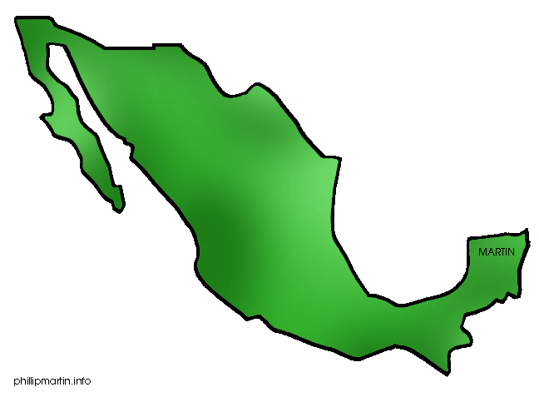
LESSON 1

- Mexico is the _______________ country in North America. It shares its entire northern border with the United States.

- This physical feature is called a ______________because it connects two geographic landforms.

- The western side of Mexico is part of the Ring of Fire. The Ring of Fire is the area where the _______________ plate collides with other tectonic plates, creating areas of seismic activity with earthquakes.

- The mountains that stretch along the northwestern edge of Mexico are called the ___________________.

- ____________________is considered the southern extension of the Rocky Mountains of Canada and the United States.

- Between these two mountain ranges is the inland __________Plateau. Moderate, consistent temperatures make this area an attractive place to live.

- The ________________is broken into two parts, the huge ___________(Northern Plateau) and the smaller but

heavily populated _______________(Central Plateau).

- The dry _________________is home to several large cities. The _______________is considered the breadbasket, or major grain producing region of Mexico.

- The variety of landforms in Mexico from large plateaus and valleys to long mountain ranges and highlands has

made it possible to support large communities of __________.

- The _____________density in Mexico is greater near parts that have the most___________, especially on the

Central ___________________________________.

- Known as the Río Bravo del Norte in Mexico, it forms part of the border between _________and ___________.

- The _______________ is one of Mexico’s most important rivers. It begins in the Toluca Basin, on the Central Plateau west of Mexico City.

- The Lerma River feeds into Lake _________, the largest natural lake in Mexico.

- _________________ is the large body of water that forms Mexico’s east coast.

- The ________ of a particular region inevitably affects the way of life that people have in each place. For example,

people who graze cattle on the northern ____________anxiously await rain each year.

- The farmers in the valleys of the ________ Plateau depend on their climate to help them get enough water for their crops.

- The three factors that influence Mexico’s climates are the regional ______________, _______________, and the

_____________.

- ________________ systems keep the north and central parts of Mexico dry and cause occasional droughts.

- Vertical climate zones create the __________________________ found throughout the southern part of Mexico.

- The _____________of the highlands keeps them at a comfortable temperature that is also helpful for growing certain crops.

- Northern Mexico is defined as a ______________. It has mild, rainy winters and hot, dry summers. The plant life

consists of ________________________.

- High winds and low-growing plants make the soil in this region good for ______________. The soil is also ___________, however, so it is not good for crops.

