Mesopotamia Map activity

Directions: Use the map on the board and locate the following: Sumerian Empire and the Akkadian Empire. Then use different colored pencils to shade in where the empires are located on this map. Afterwards, add the 4 elements of a map: Compass Rose, Title, Scale, and label your legend. Then answer the questions below the map. USE YOUR TEXTBOOK

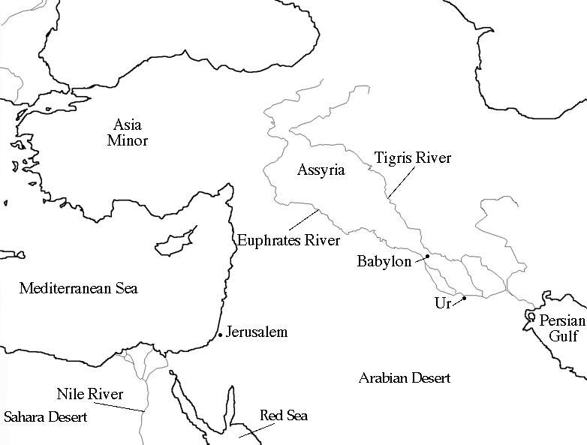

1. What continent is located on this map?

2. Write down the names of the two major rivers.

3. What is the modern day name of this region?

4. Write down the names of two modern day countries where this map is located.

5. The weather is warm to hot in this region looking at a globe where is it nearest to?

