Name:

Date: Period:

Age of Exploration Map Activity

DIRECTIONS: Complete the following steps in order to create a map of exploration Routes taken by countries during the Age of Exploration. Use a copy of the colored maps for assistance. Neatly label and color as you work!!
1.) Color all land in tan/brown using colored pencils or crayons.
2.) Label the following continents on the map. (North America, South America, Europe, Asia, Africa, and Australia) 3.) Choose five different colors and fill in the blank key on your map --- one color per country.
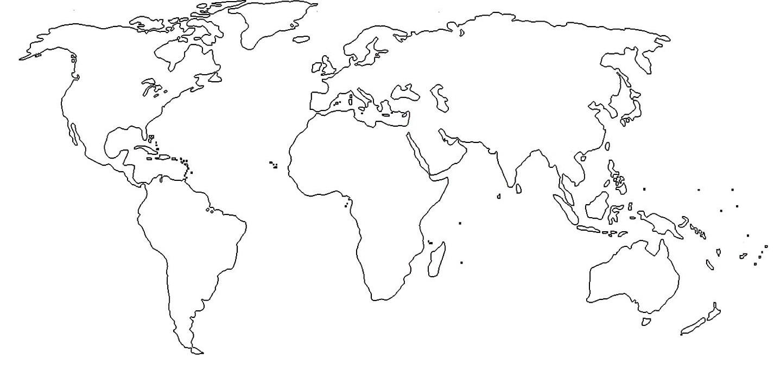4.) Draw the exploration routes (as shown on the map copy) for each of the countries using the same color. Be as accurate as possible. 5.) Now, complete the question and chart on the BACK SIDE of this assignment!!

KEY
Dutch English French Portuguese
Spanish

DIRECTIONS: Answer the following question and complete the chart. Use your Exploration Map to help answer if needed.

1.) Based on the map, which continents were not visited by European explorers?

2.) Complete the Chart below:

Exploring Country | Continents Explored by Country
Dutch
English
French
Portuguese
Spanish

