Name: _____________________ Period: _______ Date: ________ Points: 20 points

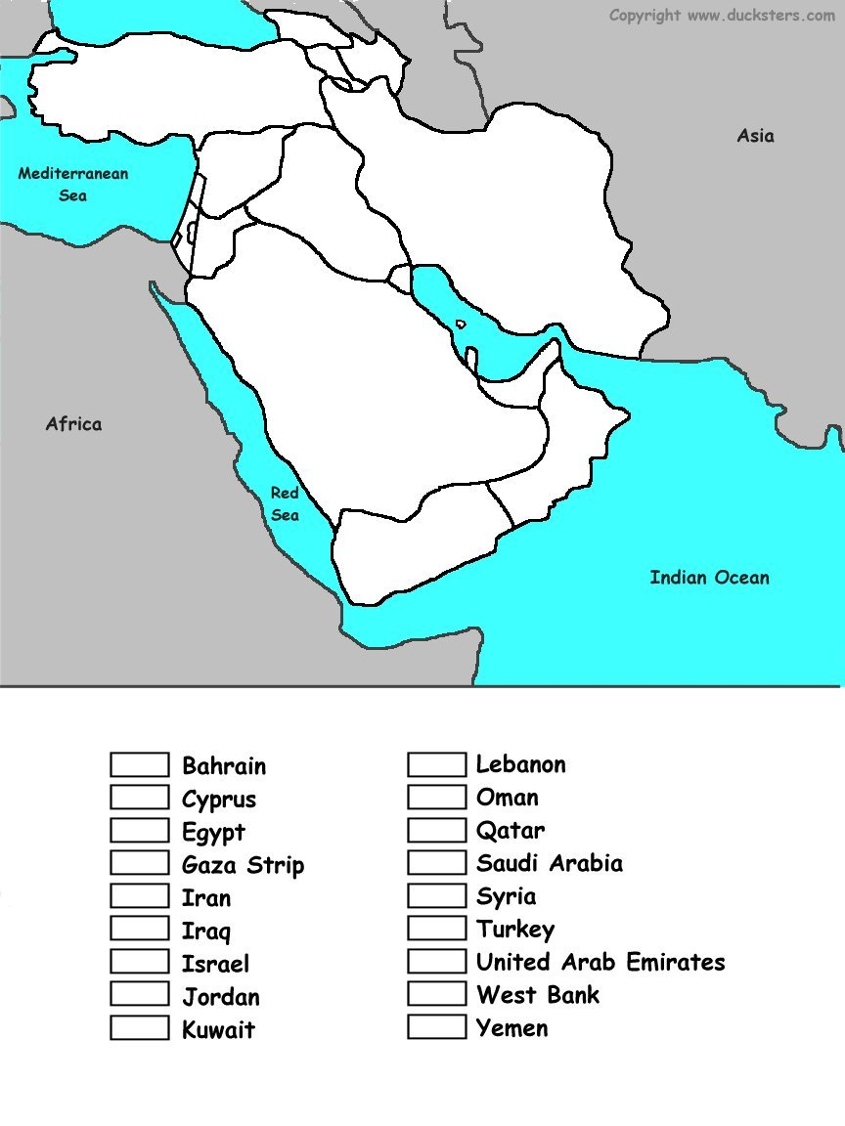
Directions: Use the maps on pages 393 and RA20 to identify each country in the key below. Then color each country a different color. Make sure you match the color to the country in the key.
Each country is worth 1 point.
3 points for being neat.

