Market Structures and Market Failures

What Is Perfect Competition, and Why Do Economists Like It So Much?
. Market structure: the organization of a market, based mainly on the degree of competition; there are four basic market structures: perfect competition, monopolistic competition, oligopoly, and monopoly]
Economists define market structure according to four main characteristics.
Number of producers. The number of producers in a market helps determine the level of competition. Markets with many producers are more competitive.
Similarity of products. The degree to which products in a market are similar also affects competition. The more similar the products are, the greater the competition among their producers.
Ease of entry. Markets differ in their ease of entry, which is a measure of how easy it is to start a new business and begin competing with established businesses. Markets that are easy to enter, with few restrictions, have more producers and are thus more competitive.
Control over prices. Markets also differ in the degree to which producers can control prices. The ability to influence prices—usually by increasing or decreasing the supply of goods—is known as market power [market power: the ability of producers to influence prices]. The more competitive the market, the less market power any one producer will have.

Perfect Competition: Many Producers, Identical Products

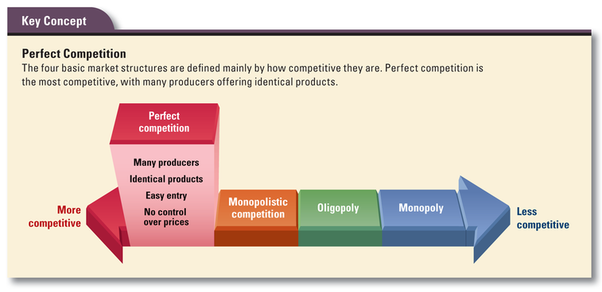
The most competitive market structure is perfect competition [perfect competition: a market structure in which many producers supply an identical product and no single producer can influence its price; in such a market, prices are set by supply and demand]. Although many markets are highly competitive, perfect competition is relatively rare. transaction costs: the time and money consumers spend shopping for the best product at the best price].

Barriers to Entry Can Limit Competition
barriers to entry: an obstacle that can restrict a producer’s access to a market and limit competition].
One possible barrier is start-up costs [start-up costs: the initial expense of launching a business], It is much less expensive, for example, to open a bicycle repair shop than it is to open a bicycle factory. An entrepreneur with little financial capital might find it difficult to get into bicycle manufacturing because of the high cost of building a factory.
The mining industry offers an example of another barrier to entry: control of resources. If existing mining companies already control the best deposits of iron, copper, or other minerals, it will be hard for new firms to enter the market.

The Benefits of Perfect Competition
Nearly perfect markets are beneficial in two ways.
First, they force producers to be as efficient as possible..
Second, because perfect competition is efficient, consumers do not pay more for a product than it is worth.

What Is a Monopoly, and Why Are Some Monopolies Legal?
Most markets do not allocate goods and services in the most efficient way, they are examples of what economists call imperfect competition. Economists define imperfect competition: any market structure in which producers have some control over the price of their products; in such a market, prices are no longer set by supply and demand]

Monopoly: One Producer, A Unique Product

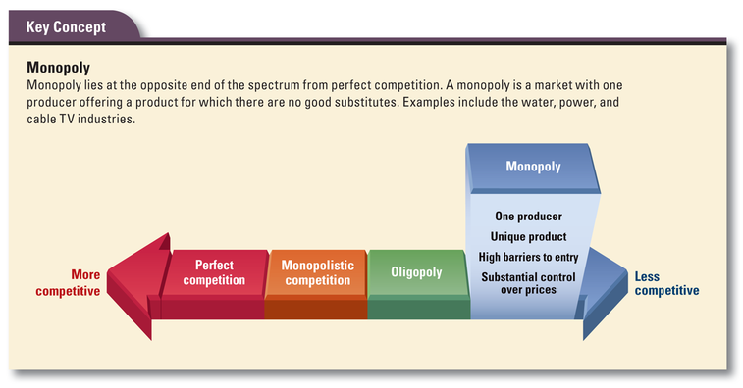
A monopoly: a market structure in which a single producer supplies a unique product that has no close substitutes]
Like perfect competition, pure monopoly is relatively rare in today’s economy. Monopolies may form and survive for a time, but they often break down in the face of competition or government regulation.
trusts [trust: a combination of firms; in the late 1800s, trusts worked to eliminate competition and control prices, but were later banned under antitrust laws]
antitrust laws: legislation designed to limit the formation of monopolies or combinations of firms that act to restrict competition]

Three Types of Legal Monopolies
- Resource monopolies. Resource monopolies exist when a single producer owns or controls a key natural resource. Other firms cannot enter the market because they do not have access to the resource
- Government-created monopolies. Government-created monopolies are formed when the government grants a single firm or individual the exclusive right to provide a good or service. The government does this when it considers such monopolies to be in the public interest. Government-created monopolies may be formed in three ways:
- Patents and copyrights. These legal grants are designed to protect and promote intellectual capital. They give inventors or creators the right to control the production, sale, and distribution of their work, thus creating a temporary monopoly over that work.
- Public franchises. A public franchise [public franchise: a contract issued by a government entity that gives a firm the sole right to provide a good or service in a certain area, such as a national park].
- Licenses. A license [license: a legal permit to operate a business or enter a market]
3. Natural monopolies. The third type of monopoly is a natural monopoly [natural monopoly: a market controlled by a single firm for reasons of efficiency; in a natural monopoly, one firm can provide a good or service at a lower cost than two or more competing firms]. For example, most utility industries are natural monopolies. They provide gas, water, and electricity, as well as cable TV services, to businesses and households. Because natural monopolies are efficient, governments tend to view them as beneficial.

What Is an Oligopoly, and How Does It Limit Competition?
The third market structure—oligopoly—is similar to monopoly. Unlike monopolies, oligopolies are quite common in the real economy. We do business with oligopolies whenever we take a domestic airline flight, buy a new car, or consume a can of soda.

Oligopoly: Few Producers, Similar Products

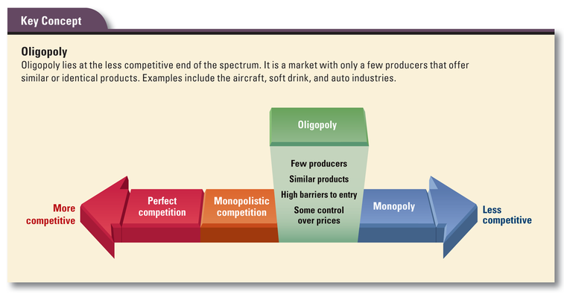
An oligopoly [oligopoly: a market structure in which a few firms dominate the market and produce similar or identical goods] Oligopoly is one of the less-competitive market structures. On our spectrum of structures, it lies closer to monopoly than to perfect competition.

Cooperative Pricing: When an Oligopoly Acts Like a Monopoly
When firms in an oligopoly compete for customers, the result can be a fairly competitive market. Often, however, oligopolies behave more like monopolies. Rather than lower their prices to try to win a larger share of the market, firms in an oligopoly may drive prices upward to levels above the market equilibrium price. They may do this in three ways: price leadership, collusion, and cartel formation.
Price leadership. In an oligopoly dominated by a single company, that firm may try to control prices through price leadership: the ability of the dominant firm in an oligopoly to set price levels that other firms then follow]. Sometimes, however, the dominant firm may cut prices to take business away from its competitors or even force them out of business. If the other firms also lower their prices, the market is said to be experiencing a price war [price war: an intense competition among rival firms in an oligopoly in which they successively lower prices to increase sales and win a larger share of the market]. Price wars are hard on producers but beneficial for consumers.
Collusion. Firms in an oligopoly may also try to control the market through collusion. Collusion [collusion: an arrangement in which producers cooperate on production levels and pricing; collusion is illegal in the United States] occurs when producers get together and make agreements on production levels and pricing. Collusion is illegal because it unfairly limits competition.
Cartel formation. A cartel [cartel: an organization of producers established to set production levels and prices for a product; cartels are illegal in the United States but do operate in global markets]

What Is Monopolistic Competition, and How Does It Affect Markets?
The fourth market structure, monopolistic competition, is the one we encounter most often in our daily lives. When we eat in a restaurant, buy gas at a gas station, or shop at a clothing store, we are doing business in monopolistically competitive markets.

Monopolistic Competition: Many Producers, Similar but Varied Products

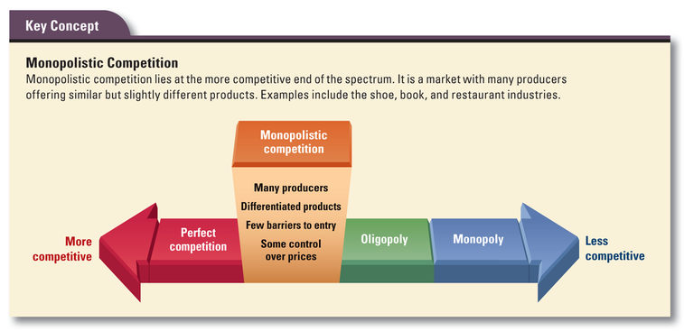
In monopolistic competition [monopolistic competition: a market structure in which many producers supply similar but varied products], a large number of producers provide goods that are similar but varied. Like oligopoly, this market structure falls between the extremes of perfect competition and monopoly. However, it lies on the more competitive end of the spectrum.

Market Failures: What Are Externalities and Public Goods?
market failures [market failure: a situation in which the market fails to allocate resources efficiently]. But imperfect competition is not the only form of economic inefficiency. Externalities and public goods are also evidence of market failure.

Externalities: Costs and Benefits That Spill Over
An externality [externality: a cost or benefit that arises from production or consumption of a good or service that falls on someone other than the producer or consumer; a spillover or side effect of production or consumption]
Externalities occur in many ways and take many forms. When a factory dumps chemical waste into a river and the polluted water affects the health of people who live downstream, that is an externality.
A negative externality [negative externality: a cost of production or consumption that falls on someone other than the producer or consumer; a negative side effect]
A positive externality [positive externality: a benefit of production or consumption that falls on someone other than the producer or consumer; a positive side effect Examples include the broader benefits of getting an education or developing a less-polluting car. Students who get a college education benefit directly by getting higher-paying jobs. But if their success also results in greater economic prosperity for their communities, that is a positive externality.

The Problem of Public Goods

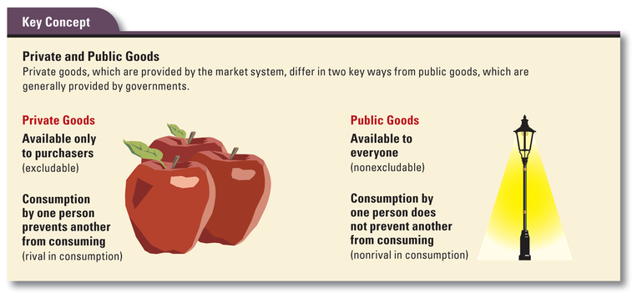
Another example of market failure involves public goods [public goods: goods and services that are used collectively and that no one can be excluded from using; public goods are not provided by markets— Examples of public goods include fire and police services, national defense, and public parks.
free-rider problem: a free rider is someone who enjoys the benefit of a good or service, such as roads or public schools, without paying for it; free riding becomes a problem when it leads to underproduction of that good or service].
Externalities and public goods remind us that markets do not always work perfectly. As a matter of fact, they do not work perfectly much of the time. However, this does not mean that the market system is fatally flawed. Despite its weaknesses, the market system is still the most effective, efficient, and flexible way for all of us to get the things we want and need.

