Name: ____________________________ Period: ________ Date: _________

Latitude and Longitude of Central Asia
Using the attached map of Central Asia, answer the following questions about latitude and longitude.

- What country is located at 45°N, 100°E? _______________________________________

- What country is located at 30°N, 55°E? ________________________________________

- If you are at 50°N, 125°E, where are you? ______________________________________

- Pretend you are traveling through Central Asia. You start at 30°N, 65°E. What country

are you in? ______________________________________________________________

- Now move 10° to the north. What is your latitude reading? What country are you in now?

________________________________________________________________________

- From your location in problem #5, move 5° westward. What is your longitude reading? Which country are you in?

________________________________________________________________________

- Now move 20° to the north and 25° to the east. What is your latitude and longitude reading? What country are you in?

________________________________________________________________________

- Which countries does the latitude line 40°N run though? _________________________

________________________________________________________________________

- Which countries does the longitude line 70°E run through? ________________________

________________________________________________________________________

- If each time zone is 15° longitude wide, starting at 45°E, how many time zones are on

this map? _____________________________________________________________

Name: _____________________________________ Period: ________ Date: _________ Points: ________

Directions: Use the colored map in order to complete the blank map below. You will have to label each of the Central Asian countries.
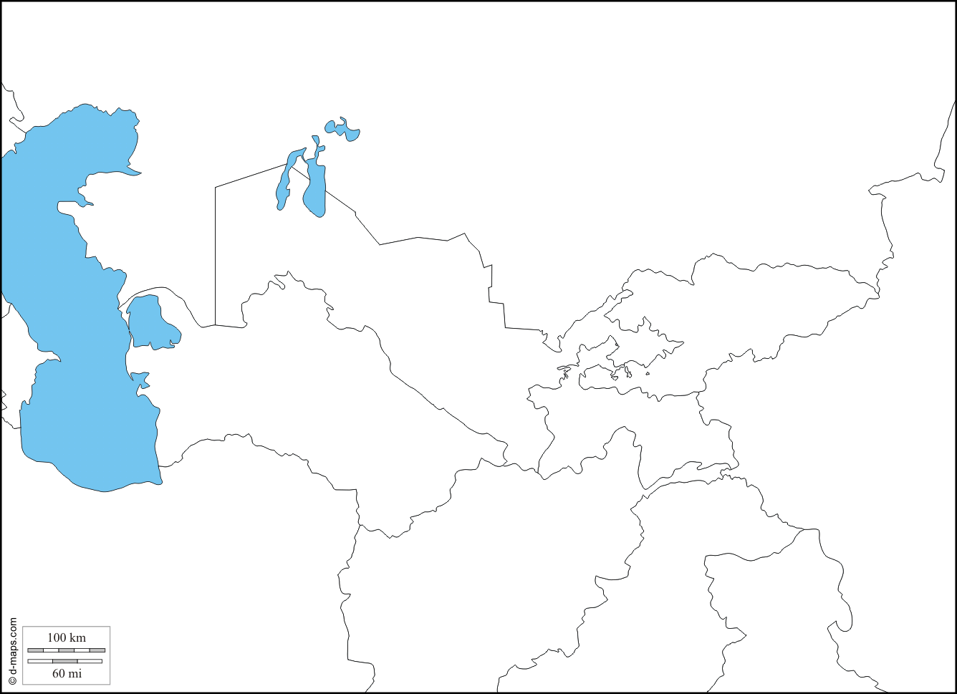

Central Asian Countries
Georgia, Armenia, Azerbaijan, Kazakhstan, Uzbekistan, Turkmenistan, Kyrgyzstan, Tajikistan, and Afghanistan.
