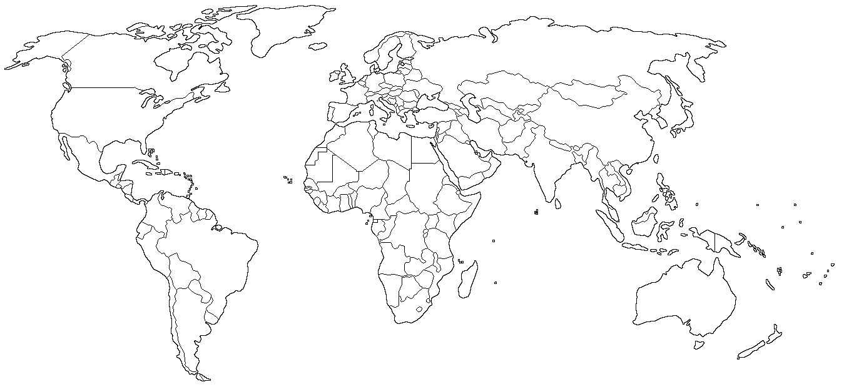

Place your key for the map below. REMEMBER ONE COLOR REPRESENTS ONE COUNTRY.

