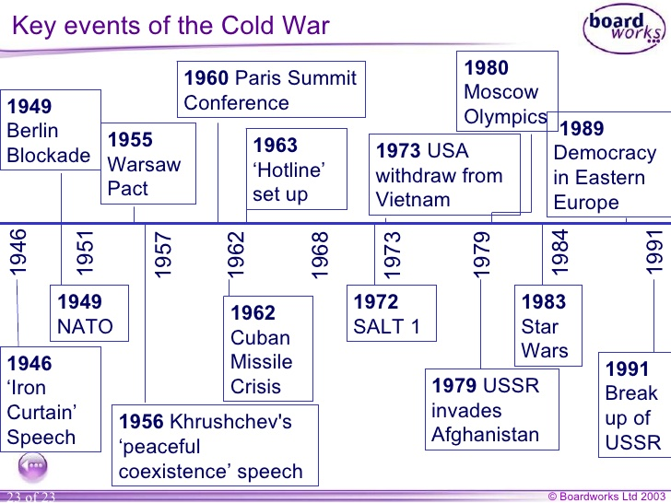

U.S History of the World 12th week 3-26 to 3-30 Friday

Monday 3-26-18 Warm up/EQ #1
How would you describe life in 1950’s America?

U.S History standard: USH. 6.1 Identify key events and individuals as well as their connections to post World War II tensions (Cold War).

Big idea: Korean War and a soldier’s perspective

Objective/Goal: Understand the similarities and differences between current wars and the Korean War.

Vocabulary words: Conform, phenomenon

Agenda:
- Daily work and rules and procedures
- Turn in all of your daily work and goal sheet from 3- 12 to 3-22
- Discuss current wars and Korean War
- Medal of Honor video-Korean War recipient https://www.youtube.com/watch?v=gTnmDQVMank 14 minutes
- Write a summary of the video and turn it in before you leave

Reflection question:
Is it possible we will still be in Iraq or Afghanistan in 50 years?

Homework:
- You should be reading chapter 23
- Bring your textbook tomorrow & Wednesday Checking for ownership
- Word Wall cards are due on Friday Conform, phenomenon
- Quiz covering chapter 22 on Friday

Tuesday 3-27-18 Warm up/EQ#2
Why did America fear Communism?

U.S History standard: USH. 6.1 Identify key events and individuals as well as their connections to post World War II tensions (Cold War).

Big idea: Red Scare

Objective/Goal: Complete today’s notes and understand the effects of McCarthyism and the Red Scare during the 1950s.

Vocabulary words: Red scare, allegations, suspicion

Agenda:
- Daily work and rules.
- Notes- Covering Red Scare and McCarthyism
- Video covering McCarthyism-must take notes
Edward R. Murrow: "A Report on Senator Joseph R. McCarthy"
https://www.youtube.com/watch?v=-YOIueFbG4g
- Exit slip one way Journalism is the same and one way Journalism is different. Must hand it in before you leave.
- Check textbooks. Need to make sure you have the right textbook.

Reflection question:
What would be considered today’s Red Scare?

Homework:
- Read chapter 23
- Bring your textbook tomorrow- penalty points if you do not have it!
- Word wall cards are due on Friday Conform, phenomenon

Wednesday 3-28-18 Warm up#3
How did popular culture effect people during the 1950’s?

U.S History standard: USH.6.4 Summarize key economic and social changes in post-WW II American life.

Big idea: Popular culture of 1950’s America

Objective/Goal: Complete today’s study guide in order to understand the culture of America during the 1950’s.

Vocabulary words: From the day’s activities

Agenda:
- Daily work
- You must update your goal sheet- due next time we update daily work.
- Study guide on chapter 22 Study guide (part 2) it is due before you leave

Reflection question:
In what way is the United States the same as 1950’s?

Homework:
- Read chapter 23
- Word wall cards are due on Friday Conform, phenomenon

Thursday 3-29-18 Warm up#4
How did TV effect Americans during the 1950s?

U.S History standard: USH.6.4 Summarize key economic and social changes in post-WW II American life.

Big idea: Life during the 1950’s

Objective/Goal: Complete today’s activities to understand daily life for America’s youth in the 1950s.

Vocabulary words: From the day’s activities

Agenda:
- Daily work
- Video Clip on 1950’s USA
http://learn360.infobase.com/p_ViewVideo.aspx?xtid=77062&loid=332102&custompage=1
- Discussion on Video clip
- Finish study guide

Reflection question:
Describe how the American youth today are similar to those in the 1950’s?

Homework:
- Read chapter 23
- Word wall cards are due tomorrow Conform, phenomenon

Friday 3-30-18 Warm up/EQ#5
What were some of the worries of Americans during the 1950s?

U.S History standard: USH.6.4 Summarize key economic and social changes in post-WW II American life.

Big idea: Government during the 1950s

Objective/Goal: Understand how government played effected American society during the 1950s.

Vocabulary words: From today’s activities.

Agenda:
- Daily work/ turn in your word wall cards
- Quiz chapter 22
- Video – Legends of tomorrow “Night of the Hawk”

Reflection question:
How is our government similar to the government we had in the 1950s?

Homework:
- By now you should have read of all of chapter 23
- We will finish chapters 22-23 and test on it when we get back from spring break

